Scole Parish flooding, 23rd-24th December 2020
- Summary
December 2020 was a very wet month with local rainfall being measured at 108mm, approximately 195% of the long term average (LTA). The River Waveney was already in flood when on the 23rd December there was heavy rain in the morning, followed by further very heavy rain in the evening and through the night. By midnight various areas of the Parish were flooded, including the main road into Diss (A1066) and the A143.
Residents reported that the floods were the 2nd worse in memory, with the flooding of 1968 being the most severe.
Flooding events have occurred previously but this time everything happened very quickly which has not been experienced before.
The Waveney was a raging torrent, fed by the three feeder systems that were also over capacity and carrying much more water than is usual when in flood. Damage to the banks of the Waveney at Scole Bridge was severe with some 2m depth of bank being destroyed, including our local Water Vole community. More worrying is the bank erosion around the high pressure sewer access chamber that is now within 2m of the river itself.
Scole Parish Council are extremely concerned that with climate change predictions estimating 30% more rainfall and for this to fall in more extreme events, these flooding incidents will become more common and more damaging.

- Damage to property
The areas and associated properties flooded were:
Scole Village:
- The Terrace (5 properties)
- Low Road (3 properties)
- 16 Karen Close (reached the level of the back door but no ingress)
- Willow Lodge Bridge Rd.(entered conservatory)
- Rear gardens in Clements Close (6 properties)
Waterloo:
- Waterloo Lane. Bungalows on southern side of lane.
- Cottage and outbuildings The Dairy, Diss Rd, Waterloo.
- Two Bungalows on Diss Rd, Waterloo.
- Campsite at Waterloo including the house.
- Kombat warehouses.
- Outbuildings at Flax Farm (Chickens drowned)
Billingford:
- Billingford Horseshoes Pub and surrounding cottages (3 properties)

- Analysis of the problem

- Excessive December rainfall
Rainfall in December was locally measured at 108mm, which equates to 195% of the long term average (LTA) for the area. That being said, although the ground has been this saturated on previous occasions, there seemed to be more water flowing in the Rivers through the Parish than expected.
Three catchment areas feed into the River Waveney prior to its traverse West – East through the Parish. These are detailed below:

Catchment Area (1) - Upper Waveney and Tributaries
Rainfall yield
108mm/hectare = 1080cubic metres/hectare
Catchment area of both sections
17.24sq.miles + 8.29sq. miles = 25.53 sq. miles
25.53 sq. miles = 6612.24 hectares
Volume of water falling on catchment areas.
Cu.m./hectare x No of hectares =
1080 x 6612.24 =
7,141,219,2 cubic metres

Catchment Area (2) - Frenze Beck
Rainfall yield
108mm/hectare = 1080cubic metres/hectare
Catchment area of FB
14.5 sq. miles.
14.5sq. miles. = 3756 hectares
Volume of water falling on FB catchment area.
Cu.m./hectare x No of hectares =
1080 x 3756 =
4,056,480 cubic metres

Catchment Area (3) - Dickleburgh Stream
There is some concern that the flooding of Dickleburgh Moor has exacerbated the situation by removing a large attenuation feature on this watercourse.
Rainfall yield
108mm/hectare = 1080cubic metres/hectare
Catchment area of this section
14.36 sq. miles
14.36 sq. miles = 3720 hectares
Volume of water falling on Catchment.
Cu.m./hectare x No of hectares = x
1080 x 3720 = 4,017,600
4,017,600 cubic metres (metric Tonnes)
Note: This combines with the Frenze Beck catchment before reaching the Waveney.

Total River Waveney volume flowing through Scole Bridge in December.
It is probably a fair assumption that all this water ultimately has to flow through Scole Pocket Park.
This gives a grand total of 15, 215,299 cu. metres.
There are 2.63x10⁶ seconds in a month so for December. this equates to some 6m³ /second of water flowing under Scole bridge on average.
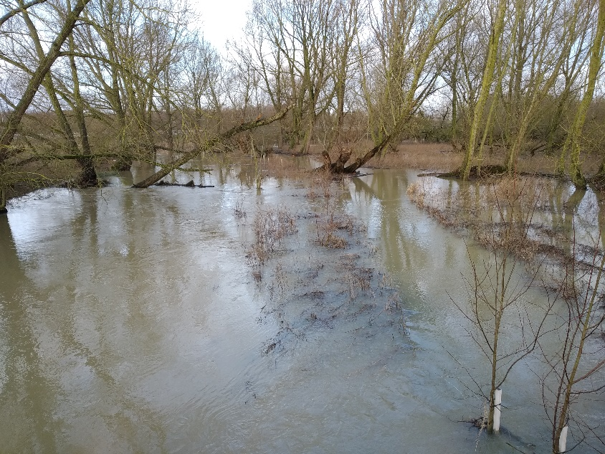
It would be very interesting to know how these figures compare with current assumed flow rates.
Without dredging, bank maintenance (including back-up ditches and dykes to facilitate flood plain management), fallen tree clearance etc., of which little or none is performed on the Waveney currently, it is difficult to see how the flooding situation will improve.

Image 1 – Trees partially blocking the river at Scole

- Poor drainage in Scole Village
There are several problems that affect two particular areas within the village:
- The Terrace:
This sits at the lowest point on Norwich Road in the centre of the village. The main problem is that the water that accumulates in the area does not have adequate drainage to the river.
Water runs down Norwich Road from the direction of the Church on the Eastern side of the road where there are no drains, these being on the opposite side. The flow of water then crosses the road close to the War Memorial, down a slope and along the front of the Terrace to the only drain (which is a grated pipe which is commonly blocked with detritus).
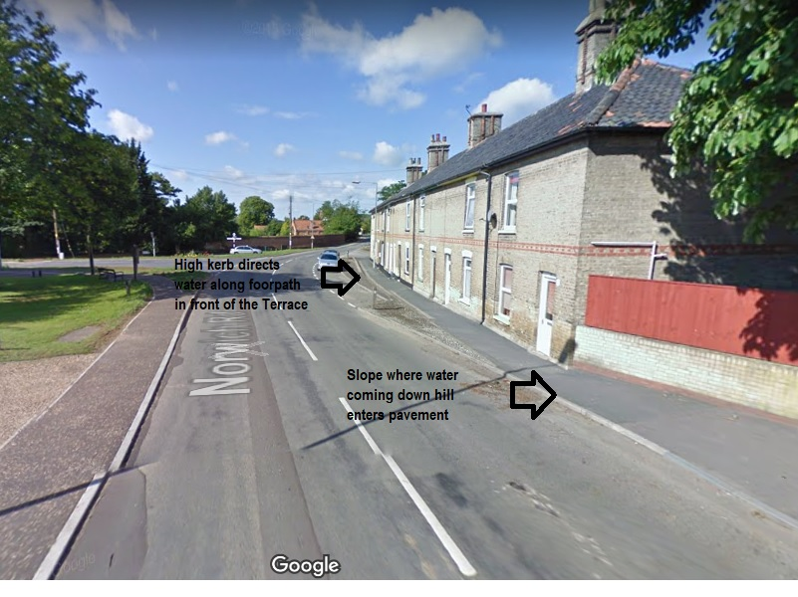
Image 2 – Norwich Road looking South towards The Terrace

Another problem is the flow of water down Low Road. This has been a problem since the building of the A140 dual carriageway and the rainwater management from the attenuation pond/leaky dam on the West of the A140, under the road and then down Low road is appalling. Many acres of farmland drain into the leaky dam catchment and emerges from a 600mm pipe under the A140 at the North end of Low Rd. There follows a trail of blocked pipes, damaged drains, undersize pipes installed by both official bodies and local householders, blocked ditches and a plethora of other deficiencies that end up with a torrent down Low Road and a lake outside (and inside) the Terrace. In the near future 18 new homes and a Village Hub will also be directing rainwater to this already overloaded system.

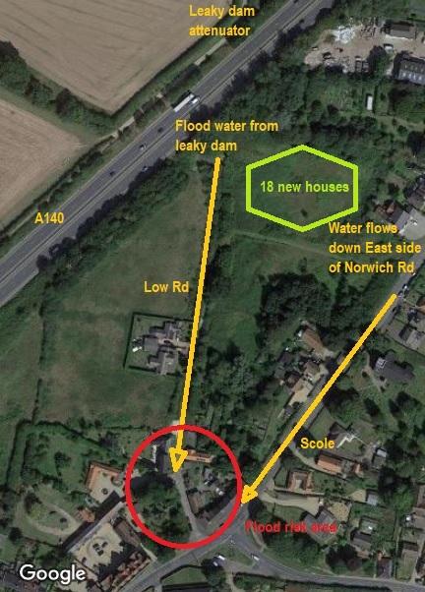
Image 3 – Aerial view of The Terrace, Scole

- Clements Close
The rear gardens of Clements Close back on to a parcel of land that was originally flood plain for the Waveney until the A143 was built and various landscaping measures were undertaken, largely to ameliorate the flood risk. This parcel of land (known as “Lot 2” in local parlance) is now drained by a large ditch along the southern rear boundaries of the gardens which takes the water under the A143 to the river. The problem is that the water level in this ditch is obviously at the same level as the river, thus rendering it useless as a drain when the river is high. Even when the river is not in flood the pipe under the A143 is partially blocked exacerbating the problem.
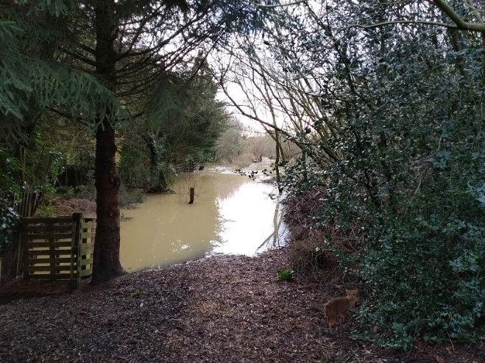

Image 4 – Ditch at rear gardens, Clements Close, Scole

- Poor drainage at Waterloo & A1066
Waterloo is a small hamlet on the South side of the A1066 between Scole and Frenze Bridge, the parish boundary with Diss. The problem here is that the River Waveney is to the South, Frenze Beck to the West and high ground (farmland) to the North. At times of heavy rainfall the runoff from the farmland opposite ends up flooding the A1066. There is nowhere for the water to go as the road drainage system is in poor condition and secondly, if the river is in flood, the water has nowhere to flow to anyway.
Local residents recall that historically there were numerous drainage ditches to take excess water down to the river which would remove some of the runoff water before it accumulated and flooded the houses. Of course, those were also the days when the river was regularly dredged so the problem was avoided on most, but agreed, not all, the flood risk situations.
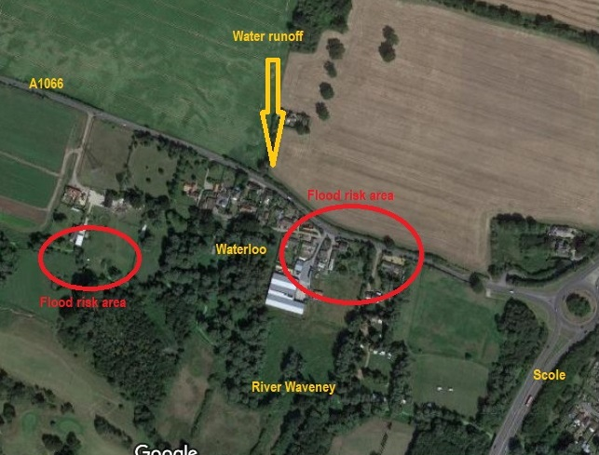
Image 5 – Aerial view of Waterloo

- Poor drainage at Billingford & A143
The situation at Billingford crossroads is similar to that at Waterloo inasmuch as there is steeply rising farmland to the North, a low spot at the crossroads with poor drainage, and the River Waveney to the South.
The A143 often has standing water during heavy rain and when the river is in flood there is nowhere for this water to go, even if the drains did function satisfactorily.
Again, in times past, the fields and roads were smaller with more field and roadside ditches with adequate road drainage.

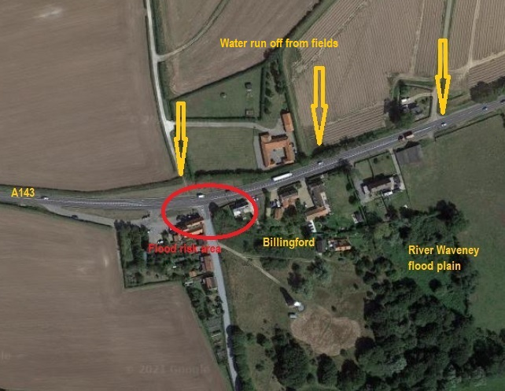
Image 6 – Aerial view of Billingford (Google image)

Graham Moore
Chairman, Scole Parish Council
18th February 2021

